HW4

Chaonan Shi

1901412

1.a





Analysis:

For color palette, I used blue-teal to display the levels of *FoodServices*; deeper color represent higher number of *FoodServices;*

For display strategy, I used log2 to display difference of levels, and used map layers to display the U.S. only;

Summary:

Since we are going to display only one category in the specific country, so that we should avoid various color to mess up the judgment. The strategy should be simple and straight:

1. highlight the area where you wish;
2. 2. Display the levels by using the neighbor colors;

As showing on the choropleth graph, we can summarize that the change of FoodServices for 1997 and 2007 are roughly at same level.

1.b:





Analysis:

For color palette, I used Red-Green-Gold diverging to display the levels of *FoodServices*; red color representing higher number of *FoodServices;* and green color representing lower number of *FoodServices;*

Summary:

For the Tile-gram, since we cannot observe the size of each state, so that we need map them manually, and also set color palette by using pastels instead of primary color. Moreover, the red always gives me the intuition of “heavy” and “more”, so I just reversed the color palette for better display.

For comparing: the choropleth gives us more geometrical information based on the actual map compare with the tile-gram. However, in some cases, it might makes audience too hard to read actual data and information, for instance, we have to pay closer attention to small states, for example, Hawaii and Washington, to compare with large states, California and Texas.

On the other hand, the Tile-gram gives us more detail about the data information not geometrical, which let us focus on the specific categories. Of course, the are some drawback for Tile-gram, for example, we may miss the geometrical factor which could highly correlate with data value. For instance, the large states tend to have more *FoodServices* comparing with small states. This problem may also lead audience missing important factor to interpret their result.

2.a

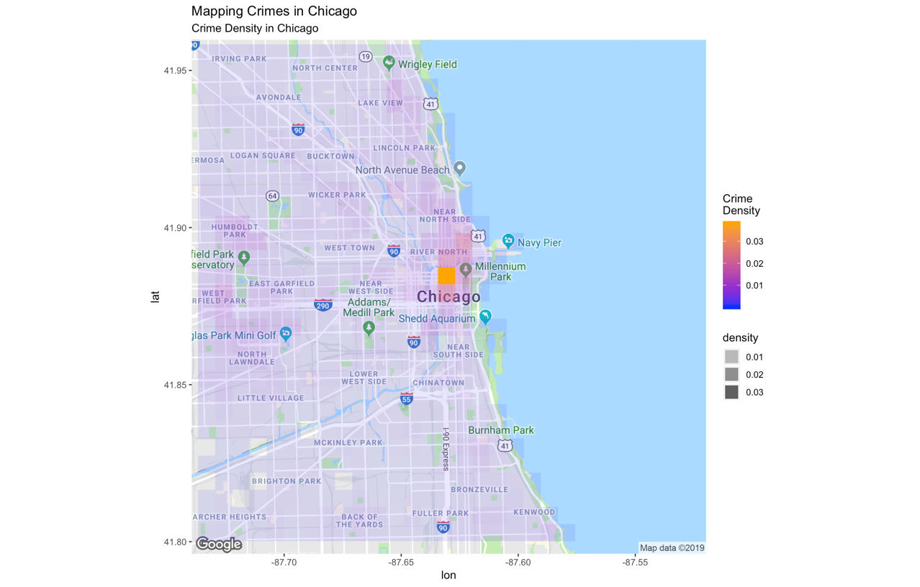

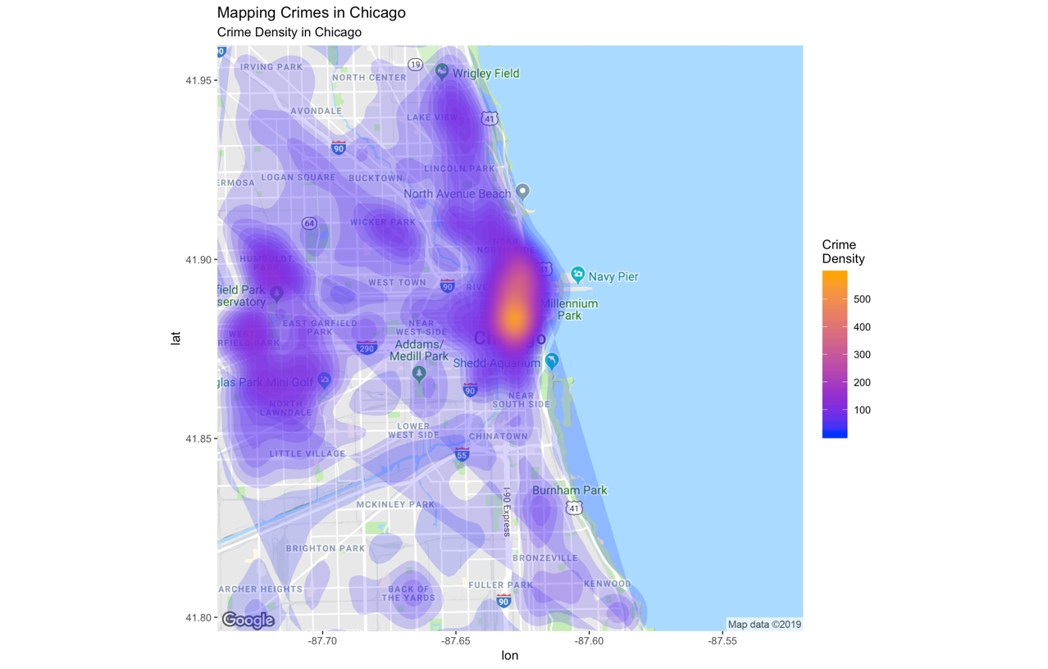

For making the hexbin and better display, I change bins from 20 to 50, and choose geom = ‘polygon’;

2.b

(By using Google map)

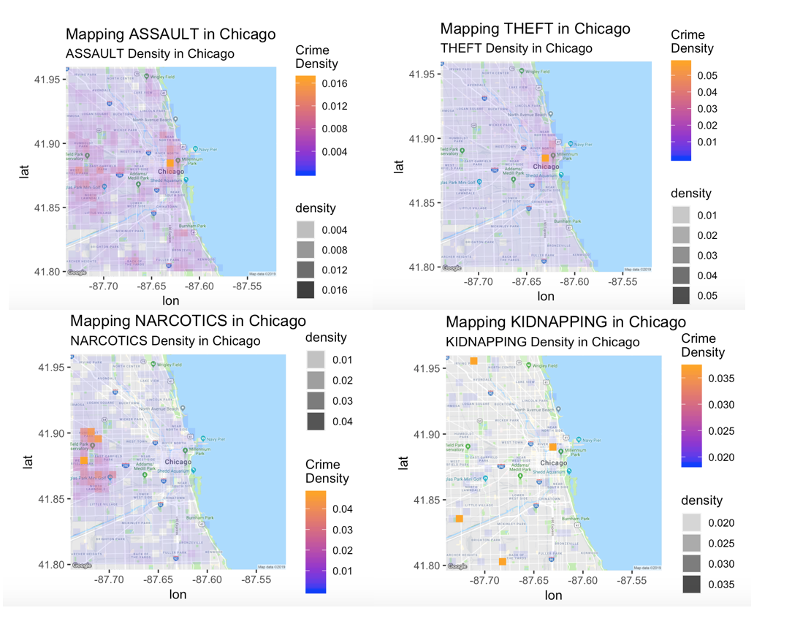

(By using posted Geometry map)

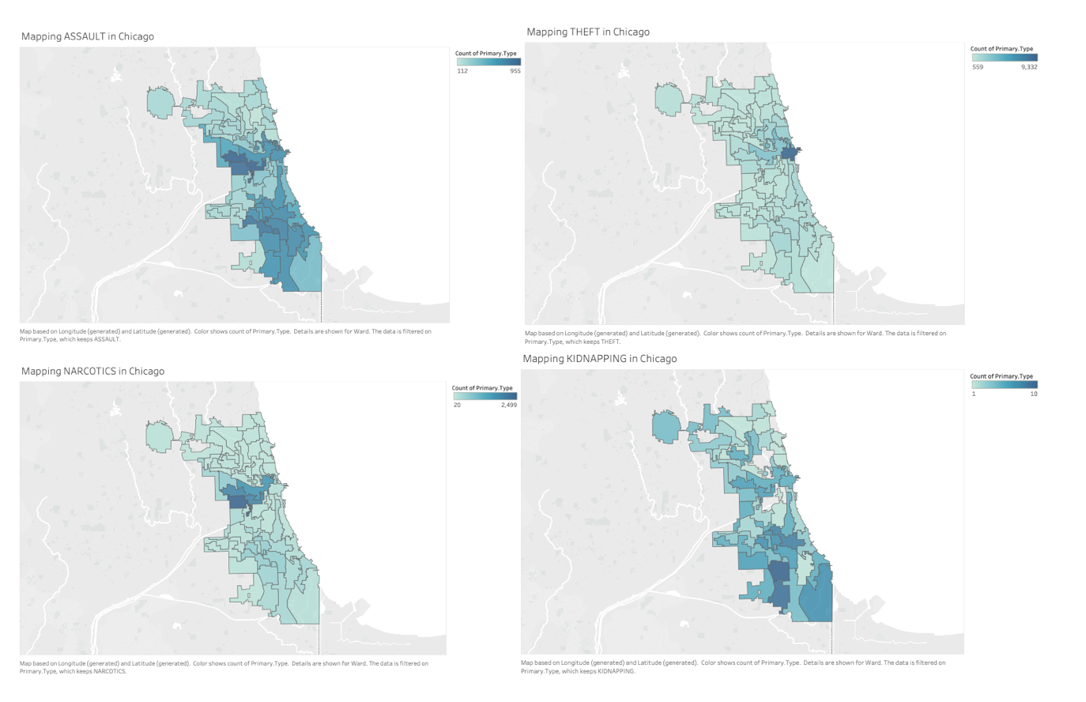

Analysis:

According to the above graph:

most of the ASSAULT happens at the “center loop” and “west loop”;

most of the THEFT happens at the “center loop” ;

most of the NARCOTICS happens at the “west loop”;

KIDNAPPING is quite special, since this crime does not happens too much, so we can clearly see where the crime happens at;

Summary:

Obviously, due to the number of crimes happened for different crime types, observations also give us different display, for instance, the ASSAULT and THEFT happened more that others, typically the KIDNAPPING only happened several times, so that we cannot plot the density and polygon for this crime.

3.a



Analysis:

In this question, I mapped data into X coordinate and Y coordinate, then change the X and Y to the dimension, color the map by using Z and chosen Orange-Blue- White Diverging to display the mountain top.

3.b

From RStudio:

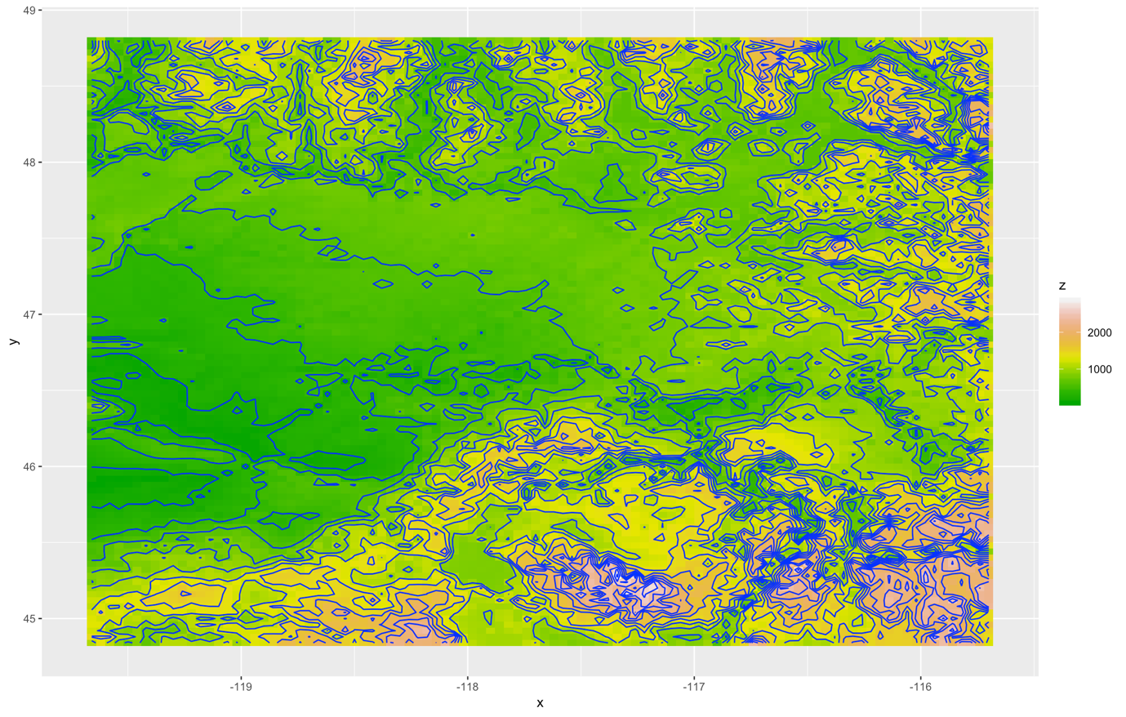

From Tableau:



3.c

Analysis:

According to the above graphs:

The R produces much more detail about the height and contour curve overlay;

The Tableau produces less information in this case, but I made slightly change for contour plot which we could differentiate two graphs;

Summary:

Obviously, contour plot gives you essentially a "topographic map" of a function. The contours join points on the surface that have the same height. The default is to have contours corresponding to a sequence of equally spaced z values. Contour plots produced by the R are by default shaded, in such a way that regions with higher z values are lighter or deeper.

For general Heatmap, it focuses on the difference of Z which is height but omit the geographical features.